**Homework3**

Xiongming Dai

Problem 1

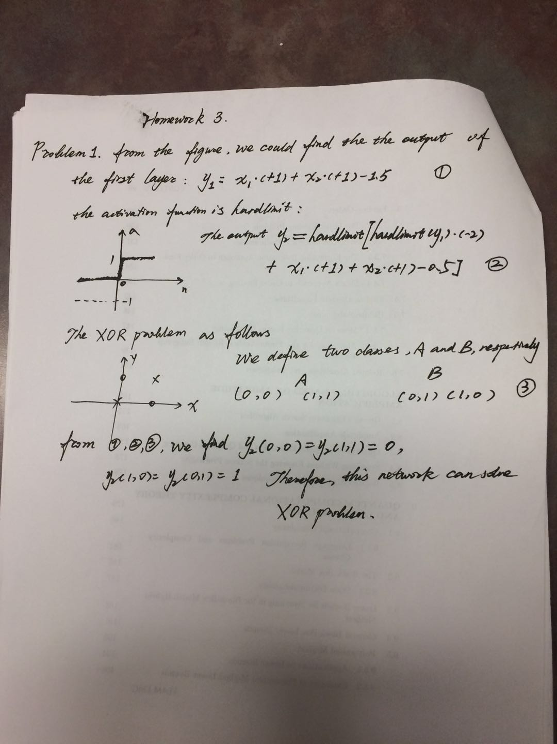

Problem2

**The code of bp2.m is filled as follows:**

%%%%%%%%%%%%%%%%%%%%%%%%%%%

%%% Type your code here %%%

for i=1:Q

%The first layer

X1=[Ptrain(:,i) 1]*W1';

X1=beta*X1;

Y1=tanh(X1);

d1=beta*(1-Y1.^2);

%The second layer

X2=[Y1 1]*W2';

Y2=purelin(X2);

d2=1;

%error computing

error=Ttrain(:,i)-Y2;

error_sum=error'*error/Q;

MSE(iter)=MSE(iter)+error_sum;

%partial differentiate for the parameters

P_D2=diag(d2)*error;

error_2=W2(1:m,1:M)'*P_D2;

P_D1=diag(d1)*error_2;

%compute the parameters and update the weight

P2=P_D2*[Y1' 1];

W2=alpha*P2+W2;

P1=P_D1*[Ptrain(:,i)' 1];

W1=alpha*P1+W1;

end

%%%%%%%%%%%%%%%%%%%%%%%%%%%

%%%%%%%%%%%%%%%%%%%%%%%%%%%

%%% End of your code %%%

Error_Matrix=Ttest-bp2val(Ptest,W1,W2,beta);

MSEnew=norm(Error_Matrix)^2/q;

%%%%%%%%%%%%%%%%%%%%%%%%%%%

**The code of bp2val.m file is completed as follows:**

[n,Q]=size(P);

[m,M]=size(W2);

% Forward step code (10 pts)

y=zeros(m,Q);

%%%%%%%%%%%%%%%%%%%%%%%%%%%

%%% Type your code here %%%

for i=1:Q

X1=[P(:,i) 1]*W1’;

X1=beta*X1;

Y1=tanh(X1);

X2=[Y1 1]*W2’;

Y2=purelin(X2);

y(:,i)=Y2;

end

**The code of q2p1.m file is completed as follows:**

%%%%%%%%%%%%%%%%%%%%%%%%%%%

%%% Type your code here %%%

%%%%%%%%%%%%%%%%%%%%%%%%%%%

Error_matrix=Tverif-Yverif;

N=length(Tverif);

mse=norm(Error_matrix)^2/N;

%%%%%%%%%%%%%%%%%%%%%%%%%%%

The network with 15 hidden neurons, trained with 300 samples,100 samples are validated, 50 samples are tested. From shown as follows, there is a approximate tendency between the outputs from the neuron network and the ground truth from the actual function.

We also can do many experiments by change the number of hidden neurons, and we can demonstrate the robustness of our framework. Figure 2 and 3 shows the analysis of robustness.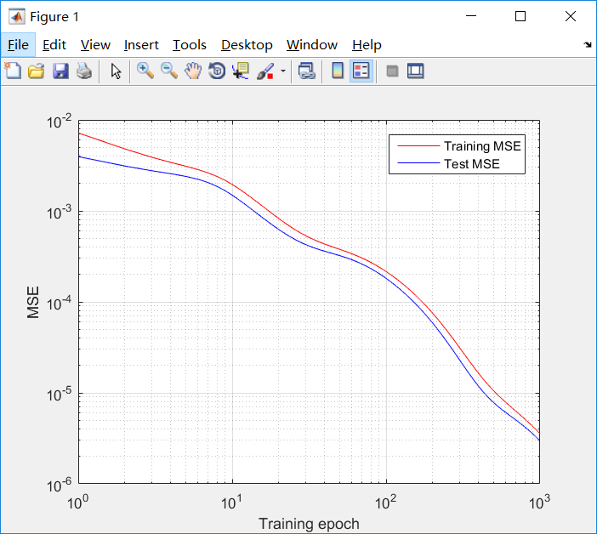

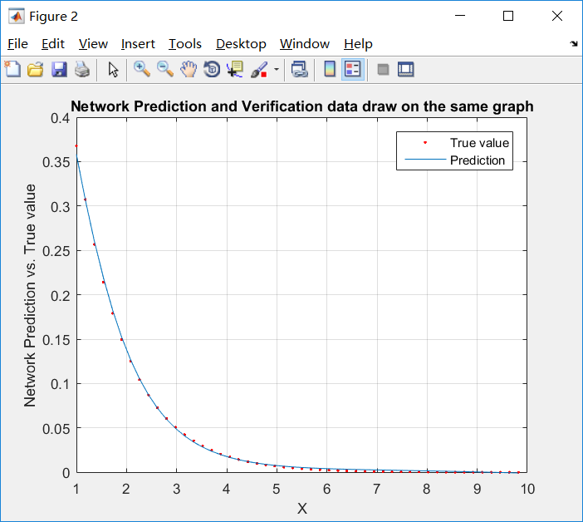

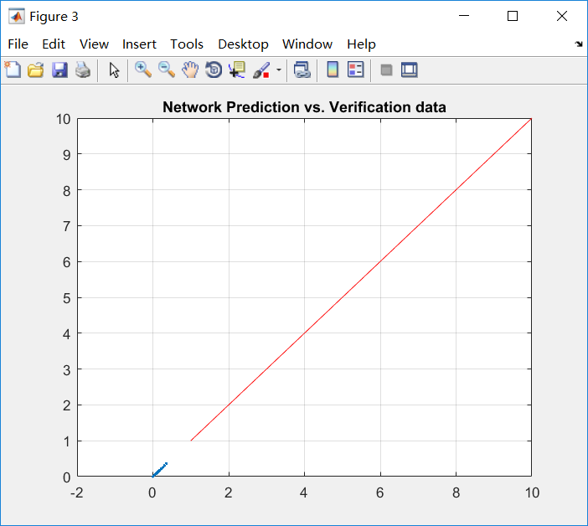

**The code of q2p2.m file is completed as follows:**

%%% Type your code here %%%

%%%%%%%%%%%%%%%%%%%%%%%%%%%

Error_matrix=Ttest-Yverif;

N=length(Yverif);

mse=norm(Error_matrix)^2/N;

%%%%%%%%%%%%%%%%%%%%

We use the Nguyen-Widrow weight initialization algorithm, and it reduce the time to converge. Figure1 is the ground truth,figure 2 is the analysis of error, Figure 3 is the validation analysis, Figure 4 is the value from the neuron network. We can do the experiments with different numbers of hidden neurons, we find the error is reduced obviously, when the hidden neurons are up to 22.

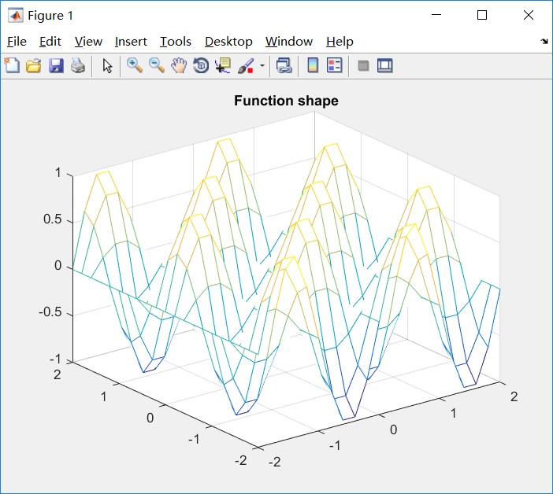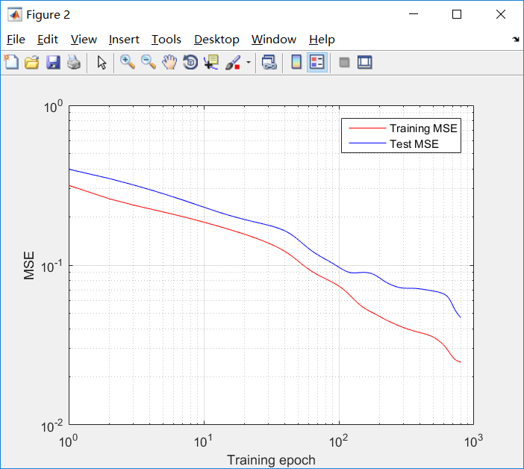

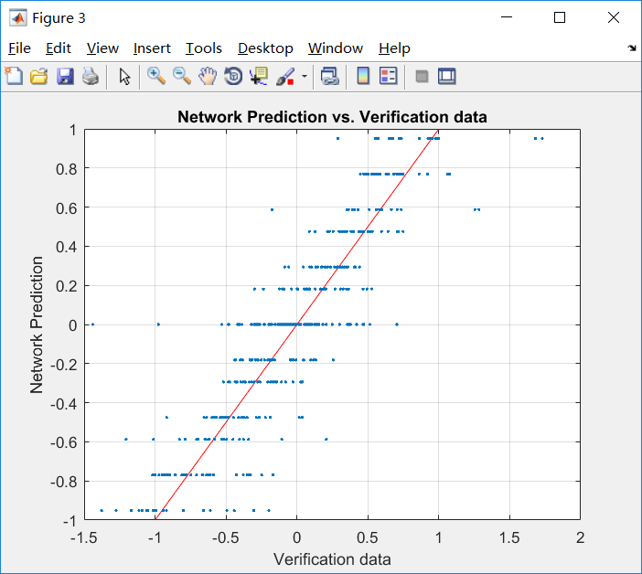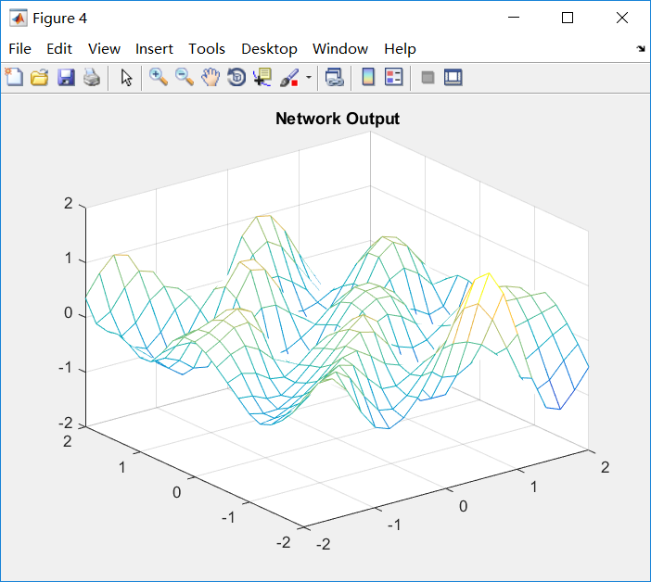

**The total code is as follows:**

**bp2.m**

function [W1, W2, E]=bp2(Ptrain, Ttrain, Ptest, Ttest,M,Tp,W1,W2);

% BP2: MLP NN with one hidden layer trained using backpropagation

%

% [W1, W2, E]=bp2(Ptrain, Ttrain,Ptest, Ttest,M,Tp,W1,W2);

% Ptrain: n by Q matrix with Q, n-dimensional training input vectors.

% Ttrain: m by Q matrix with Q, m-dimensional training output vectors.

% Ptest: n by q matrix with q, n-dimensional testing input vectors.

% Ttest: m by q matrix with q, m-dimensional testing output vectors.

% M: number of neurons in the hidden layer

% Tp:training parameter vector

% Tp(1): learning rate;

% Tp(2): maximum % number of iterations;

% Tp(3): slope of the activation function, f(x)=tanh(beta*x);

% Tp(4): stopping condition; The learning is stopped if the error for

% testing data increases by Tp(4)

% Tp(5): weights initialization option. if Tp(5)=0-random weights

% initialization; else use Nguyen-widrow initialization;

% W1: weights from the input to the hidden layer (includes biases)

% W2: weights from the hidden layer to the output layer (includes bias)

% E: MSE history

[n,Q]=size(Ptrain);

[m,Q]=size(Ttrain);

q=length(Ttest);

% Parameter initialization

alpha=Tp(1); % learning rate

MaxIter=Tp(2); %maximum number of epochs

beta=Tp(3); %slope of the tanh activation function, f(x)=tanh(beta*x)

Incr=Tp(4); %maximum increase of the error for the test set

NgyWid=Tp(5); %NgyWid=0: random initialization;

%NgyWid=1: Nguyen-Widrow initialization

E=[];

MSEold=realmax;

MSEnew=realmax;

iter=0;

%% Network weights initialization

if nargin<8

if NgyWid==0

%random initialization

W1=0.1*randn(M,n+1);

W2=0.1*randn(m,M+1);

else

%Nguyen-Widrow initialization

gamma1=0.7*M^(1/n); % Eq.(3.58)

gamma2=0.7*m^(1/M); % Eq.(3.58)

W1=-0.5+rand(M,n);

W2=-0.5+rand(m,M);

b1=zeros(M,1);

b2=zeros(m,1);

for i=1:M

W1(i,:) = gamma1*W1(i,:)/norm(W1(i,:)); % Eq. (3.59)

b1(i) = (max(W1(i,:))-min(W1(i,:)))*rand(1,1)-mean(W1(i,:));

end

W1=[W1 b1];

for i=1:m

W2(i,:) = gamma2*W2(i,:)/norm(W2(i,:)); % Eq. (3.59)

b2(i) = (max(W2(i,:))-min(W2(i,:)))*rand(1,1)-mean(W2(i,:));

end

W2=[W2 b2];

end

%% Backpropogation code (20 pts)

MSE=zeros(MaxIter,1);

while iter<MaxIter&MSEnew<=(MSEold+Incr);

iter=iter+1;

MSEold=MSEnew;

%%%%%%%%%%%%%%%%%%%%%%%%%%%

%%% Type your code here %%%

for i=1:Q

%The first layer

X1=[Ptrain(:,i) 1]*W1';

X1=beta*X1;

Y1=tanh(X1);

d1=beta*(1-Y1.^2);

%The second layer

X2=[Y1 1]*W2';

Y2=purelin(X2);

d2=1;

%error computing

error=Ttrain(:,i)-Y2;

error_sum=error'*error/Q;

MSE(iter)=MSE(iter)+error_sum;

%partial differentiate for the parameters

P_D2=diag(d2)*error;

error_2=W2(1:m,1:M)'*P_D2;

P_D1=diag(d1)*error_2;

%compute the parameters and update the weight

P2=P_D2*[Y1' 1];

W2=alpha*P2+W2;

P1=P_D1*[Ptrain(:,i)' 1];

W1=alpha*P1+W1;

end

%%%%%%%%%%%%%%%%%%%%%%%%%%%

%%%%%%%%%%%%%%%%%%%%%%%%%%%

%%% End of your code %%%

Error_Matrix=Ttest-bp2val(Ptest,W1,W2,beta);

MSEnew=norm(Error_Matrix)^2/q;

%%%%%%%%%%%%%%%%%%%%%%%%%%%

%%%%%%%%%%%%%%%%%%%%%%%%%%%

E=[E;MSEnew]; % storing MSE of iteration

end

%% Generating error plot

figure;

loglog(MSE,'r');

hold on;loglog(E,'b');grid;

xlabel('Training epoch');

ylabel('MSE');

legend('Training MSE','Test MSE');

hold off;

end

**bp2val.m**

function y=bp2val(P,W1,W2,beta);

%BP2VAL - output of the MLP NN with one hidden layer/ predicted values

%usage - y=bp2val(P,W1,W2,beta);

%

% P: n by Q matrix containing Q, n-dimensional input vectors

% W1: weights from the input to the hidden layer

% W2: weights from the hidden layer to the output layer

% beta: slope of the activation function, f(x)=tanh(beta*x)

% y: m by Q matrix containing Q, m-dimensional output vectors

[n,Q]=size(P);

[m,M]=size(W2);

% Forward step code (10 pts)

y=zeros(m,Q);

%%%%%%%%%%%%%%%%%%%%%%%%%%%

%%% Type your code here %%%

for i=1:Q

X1=[P(:,i) 1]*W1’;

X1=beta*X1;

Y1=tanh(X1);

X2=[Y1 1]*W2’;

Y2=purelin(X2);

y(:,i)=Y2;

end

%%%%%%%%%%%%%%%%%%%%%%%%%%%

end

**q2p1.m**

clear all; close all; clc;

Qq=[300 100 50]; % Number of train, validation and test samples

% Generate the training data

Ptrain=zeros(1,Qq(1));

Ptrain=9*rand(size(Ptrain))+1;

Ttrain=exp(-Ptrain);

% Generate the validation data

Pvalid=zeros(1,Qq(2));

Pvalid=9*rand(size(Pvalid))+1;

Tvalid=exp(-Pvalid);

% Generate the test data. This time choose sequential points for plotting

Ptest=zeros(1,Qq(3));

i=1:Qq(3);

Ptest(:,i)=1+(i-1)*(9/Qq(3));

Ttest=exp(-Ptest);

% Train the network

Tp=[0.01 1000 1 0.1 0];

% Tp(1): learning rate;

% Tp(2): maximum % number of iterations;

% Tp(3): slope of the activation function, f(x)=tanh(beta*x);

% Tp(4): stopping condition; The learning is stopped if the error for

% testing data increases by Tp(4)

% Tp(5): weights initialization option. if Tp(5)=0-random weights

% initialization; else use Nguyen-widrow initialization;

M=15; % Number of neurons in hidden layer

% Function call for training

[W1,W2,E]=bp2(Ptrain,Ttrain,Pvalid,Tvalid,M,Tp);

% generate the plot for predicted data

Yverif=bp2val(Ptest,W1,W2,1);

figure;

axis([1 10 1 10]);

plot(Ptest, Ttest,'r.',Ptest, Yverif,'-');grid;

xlabel('X');

ylabel('Network Prediction vs. True value');

legend('True value','Prediction');

title('Network Prediction and Verification data draw on the same graph');

figure;

xlabel('Prediction');

ylabel('Verification data');

axis([1 10 1 10]);

i=1:0.1:10;

plot(i,i,'r-',Yverif, Ttest,'.'); grid;

title('Network Prediction vs. Verification data');

% Calculate MSE for testing data

%%% Type your code here %%%

%%%%%%%%%%%%%%%%%%%%%%%%%%%

Error_matrix=Tverif-Yverif;

N=length(Tverif);

mse=norm(Error_matrix)^2/N;

%%%%%%%%%%%%%%%%%%%%%%%%%%%

%%%%%%%%%%%%%%%%%%%%%%%%%%%

**q2p2.m**

clear all;close all;

Qq=[200 100 50];% Number of train, validation and test samples

% Generate the training data

Ptrain=zeros(2,Qq(1));

Ptrain=4*rand(size(Ptrain))-2;

Ttrain=sin(pi*Ptrain(1,:)).*cos(pi*Ptrain(2,:));

% Generate the validation data

Pvalid=zeros(2,Qq(2));

Pvalid=4*rand(size(Pvalid))-2;

Tvalid=sin(pi*Pvalid(1,:)).*cos(pi*Pvalid(2,:));

% Generate the test data. This time choose sequaential points for

% plotting

[X,Y] = meshgrid(-2:0.2:2);

Z=sin(pi*X).*cos(pi*Y);

mesh(X,Y,Z);

title('Function shape');

Ptest=[reshape(X,1,441);reshape(Y,1,441)];

Ttest=reshape(Z,1,441);

% Train the network

Tp=[0.02 800 1 0.1 1];

% Tp(1): learning rate;

% Tp(2): maximum % number of iterations;

% Tp(3): slope of the activation function, f(x)=tanh(beta*x);

% Tp(4): stopping condition; The learning is stopped if the error for

% testing data increases by Tp(4)

% Tp(5): weights initialization option. if Tp(5)=0-random weights

% initialization; else use Nguyen-widrow initialization;

M=20;% Number of neurons in hidden layer

[W1,W2,E]=bp2(Ptrain,Ttrain,Pvalid,Tvalid,M,Tp);

% generate the plots for predicted data

Yverif=bp2val(Ptest,W1,W2,1);

figure;

axis([-1 1 -1 1]);

i=-1:0.02:1;

plot(i,i,'r-',Yverif, Ttest,'.'); grid;

xlabel('Verification data');

ylabel('Network Prediction');

title('Network Prediction vs. Verification data');

figure;

X2=reshape(Ptest(1,:),21,21);

Y2=reshape(Ptest(2,:),21,21);

Z2=reshape(Yverif,21,21);

mesh(X2,Y2,Z2);

title('Network Output');

% Calculate MSE for testing data

%%% Type your code here %%%

%%%%%%%%%%%%%%%%%%%%%%%%%%%

Error_matrix=Ttest-Yverif;

N=length(Yverif);

mse=norm(Error_matrix)^2/N;

%%%%%%%%%%%%%%%%%%%%

**Problem 3:**

1.The MATLAB code is shown below

%%% Homework 3 Problem 3 part a %%%

clear all;

clc;

%% load data

IRIS3data=xlsread('IRIS 3 class dataset');

% three-dimensional input features

x=IRIS3data(:,1:4)';

% target class

t=IRIS3data(:,5)';

%% build network

net = feedforwardnet(10,'traingdm');

% learning rate and momentum constant

net.trainParam.lr=0.001;

net.trainParam.mc = 0.9;

% Set up Division of Data for Training, Validation, Testing

net.divideParam.trainRatio = 67/100;

net.divideParam.valRatio = 0/100;

net.divideParam.testRatio = 33/100;

net = train(net,x,t);

view(net)

y = net(x);

perf=perform(net,y,t)

And the performance of network is described by mean square error and shown in the following table.

|  |  |  |  |  |  |
| --- | --- | --- | --- | --- | --- |
|  |  | | | | |
|  | 0 | 0.1 | 0.5 | 0.8 | 0.99 |
| 0.001 | 3.1253 | 0.4957 | 0.4957 | 0.4886 | 0.4886 |
| 0.01 | 0.4869 | 0.4869 | 0.4869 | 0.4869 | 0.5543 |
| 0.1 | 0.2816 | 0.0864 | 0.0845 | 0.0847 | 0.0847 |
| 0.25 | 0.0849 | 0.0977 | 0.0806 | 0.0804 | 0.0804 |
| 0.99 | 0.1339 | 0.1339 | 0.1339 | 0.0774 | 0.0774 |

For this random initial weights, when the or achieve the best classification accuracy.

2.The MATLAB code is

%%% Homework 3 Probem 3_2 %%%

clear all;

clc;

%% load data

IRIS3data=xlsread('IRIS 3 class dataset');

% three-dimensional input features

x=IRIS3data(:,1:4)';

% target class

t=IRIS3data(:,5)';

%% build network

net = feedforwardnet(10,'trainlm');

setdemorandstream(491218382);

% learning rate and momentum constant

eta=[0.001 0.01 0.1 0.25 0.5];

alpha=[0 0.1 0.5 0.8 0.99];

% eta=0.5;

% alpha=0.1;

for i=1:length(eta)

for j=1:length(alpha)

net.trainParam.lr=eta(i);

net.trainParam.mc = alpha(j);

% Set up Division of Data for Training, Validation, Testing

net.divideParam.trainRatio = 66/100;

net.divideParam.valRatio = 1/100;

net.divideParam.testRatio = 33/100;

net = train(net,x,t);

% view(net)

y = net(x);

perf(i,j)=perform(net,y,t);

end

end

And the performance of network is described by mean square error and shown in the following table.

|  |  |  |  |  |  |
| --- | --- | --- | --- | --- | --- |
|  |  | | | | |
|  | 0 | 0.1 | 0.5 | 0.8 | 0.99 |
| 0.001 | 0.0948 | 0.0669 | 0.0581 | 0.0581 | 0.0581 |
| 0.01 | 0.0809 | 0.0809 | 0.0165 | 0.0171 | 0.0079 |
| 0.1 | 0.0079 | 0.3816 | 0.3816 | 0.3816 | 0.3816 |
| 0.25 | 0.3816 | 0.3816 | 0.3816 | 0.3816 | 0.3816 |
| 0.5 | 0.3816 | 0.3816 | 0.3816 | 0.3816 | 0.3816 |

For this random initial weights, when the or achieve the best classification accuracy. And the Levenberg-Marquardt variant of backpropagation has better performance with respected to classical backpropagation.

3.The MATLAB code is

%%% Homework 3 Probem 3_3 %%%

clear all;

clc;

%% load data

IRIS3data=xlsread('IRIS 3 class dataset');

% three-dimensional input features

x=IRIS3data(:,1:4)';

% target class

t=IRIS3data(:,5)';

%% build network

net = feedforwardnet(10,'trainlm');

% setdemorandstream(491218382);

% learning rate and momentum constant

eta=[0.001 0.01 0.1 0.25 0.5];

alpha=[0 0.1 0.5 0.8 0.99];

% eta=0.5;

% alpha=0.1;

for i=1:length(eta)

for j=1:length(alpha)

net.trainParam.lr=eta(i);

net.trainParam.mc = alpha(j);

% Set up Division of Data for Training, Validation, Testing

net.divideParam.trainRatio = 66/100;

net.divideParam.valRatio = 1/100;

net.divideParam.testRatio = 33/100;

% Nguyen-Widrow technique for weight initilaization

net.initFcn = 'initlay';

net.layers{1}.initFcn = 'initnw';

net.layers{2}.initFcn = 'initnw';

% net = train(net,x,t);

net2=init(net);

net2= train(net2,x,t);

% view(net)

y = net2(x);

perf(i,j)=perform(net,y,t);

end

end

And the performance of network is described by mean square error and shown in the following table.

|  |  |  |  |  |  |
| --- | --- | --- | --- | --- | --- |
|  |  | | | | |
|  | 0 | 0.1 | 0.5 | 0.8 | 0.99 |
| 0.001 | 0.3157 | 0.0682 | 0.0626 | 0.0498 | 0.1156 |
| 0.01 | 0.1133 | 0.1033 | 0.1024 | 0.0560 | 0.0833 |
| 0.1 | 0.0881 | 0.0757 | 0.0786 | 0.1103 | 3.4369 |
| 0.25 | 0.0898 | 0.0958 | 0.0533 | 0.0828 | 0.0702 |
| 0.5 | 0.1023 | 0.0776 | 0.0541 | 0.0577 | 0.0607 |

Using the Nguyen-Widrow technique for weight initialization, or achieve the best classification accuracy. And the Nguyen-Widrow technique has better performance with respected to the one using random weight initialization.

4.The MATLAB code is

%%% Homework 3 Probem 3_4 %%%

clear all;

clc;

%% load data

IRIS3data=xlsread('IRIS 3 class dataset');

% three-dimensional input features

x=IRIS3data(:,1:4)';

% target class

t=IRIS3data(:,5)';

% shuffle data: random Select 80% as training data, 20% as the test data

[n,m]=size(x); % n: number of inputs ; m: number of samples

index=randsample(m,m);

k_fold=3; % three_fold cross validation

num_sub=m*0.8/k_fold; % number of subsets used for training

%% build network

net = feedforwardnet(10,'trainlm');

% setdemorandstream(491218382);

% learning rate and momentum constant

eta=[0.001 0.01 0.1 0.25 0.5];

alpha=[0 0.1 0.5 0.8 0.99];

% eta=0.5;

% alpha=0.1;

for i=1:length(eta)

for j=1:length(alpha)

for k=1:k_fold

% define learning rate and momentum constant

net.trainParam.lr=eta(i);

net.trainParam.mc = alpha(j);

% Set up Division of Data for Training, Validation, Testing

net.divideFcn='divideind';

if k==1

net.divideParam.trainInd=index(41:120);

elseif k==2

net.divideParam.trainInd=[index(1:40)' index(81:120)']';

elseif k==3

net.divideParam.trainInd=index(1:80);

end

net.divideParam.valInd=index((k-1)*num_sub+1:k*num_sub);

net.divideParam.testIn=index(121:150);

% Nguyen-Widrow technique for weight initilaization

net.initFcn = 'initlay';

net.layers{1}.initFcn = 'initnw';

net.layers{2}.initFcn = 'initnw';

% net = train(net,x,t);

net2=init(net);

net2= train(net2,x,t);

% view(net)

y = net2(x);

perf(k)=perform(net,y,t);

end

performance(i,j)=mean(perf);

end

end

And the performance of network is described by mean square error and shown in the following table.

|  |  |  |  |  |  |
| --- | --- | --- | --- | --- | --- |
|  |  | | | | |
|  | 0 | 0.1 | 0.5 | 0.8 | 0.99 |
| 0.001 | 0.0716 | 0.0688 | 0.0778 | 0.0747 | 0.0640 |
| 0.01 | 0.0678 | 0.0650 | 0.0666 | 0.0731 | 0.0647 |
| 0.1 | 0.0731 | 0.0721 | 0.0660 | 0.0599 | 0.0713 |
| 0.25 | 0.0749 | 0.0880 | 0.0728 | 0.0626 | 0.0638 |
| 0.5 | 0.0747 | 0.0665 | 0.0665 | 0.0659 | 0.0794 |

Using the 3-fold cross validation,  achieve the best classification accuracy. And the 3-fold cross validation can effectively improve the network’s performance based on the results shown in the table.

(End)